28-11-2024

**KOVAI.CO**

**Task-1**

**Report for Transportation Usage Dataset**

**About Dataset:**

**Name**: Transportation Usage Dataset

**Columns:**

1.Date-The date when the data was recorded. This column contains timestamps for each observation.

2. Local Route-The number of passengers or users for the local route service on the corresponding date.

3. Light Rail-The number of passengers or users for the light rail service on the corresponding date.

4. Peak Service-The number of passengers or users for peak service transportation (typically during rush hours) on the corresponding date.

5. Rapid Route-The number of passengers or users for rapid transit or express services on the corresponding date.

6. School- The number of passengers or users for school transportation services (possibly buses or school-specific routes) on the corresponding date.

7. Other-The number of passengers or users for other transportation services that do not fall under the above categories.

**Data-types:** Numerical.

**Preprocess the Data:**

1. **Displaying Column Names:**

**Purpose**: List all the column names in the dataset to ensure we are working with the correct data.

**Output:**

['Date', 'Local Route', 'Light Rail', 'Peak Service', 'Rapid Route', 'School', 'Other']

1. **Handling Missing Values:**

**Purpose**: Check for missing values (NaN) in the dataset and visualize their distribution.

**Output:**

Date 0

Local Route 0

Light Rail 0

Peak Service 0

Rapid Route 0

School 0

Other 20

**Impute Missing Values**: You can fill missing values in the **'Other'** column (which has 20 missing

values) using an imputation technique such as filling with the mean, median, or a placeholder value like 0.

**After preprocess Missing Values output:**

Date 0

Local Route 0

Light Rail 0

Peak Service 0

Rapid Route 0

School 0

Other 0

**Descriptive Statistics:**

**Purpose**: Generate summary statistics to understand the central tendencies, spread, and range of the numerical data.

Date Local Route Light Rail Peak Service

count 1918 1918.000000 1918.000000 1918.000000

mean 2022-02-13 12:00:00 9891.395203 7195.446298 179.581335

min 2019-07-01 00:00:00 1.000000 0.000000 0.000000

25% 2020-10-22 06:00:00 3044.500000 4463.500000 0.000000

50% 2022-02-13 12:00:00 11417.000000 7507.000000 193.000000

75% 2023-06-07 18:00:00 15517.500000 10008.250000 313.750000

max 2024-09-29 00:00:00 21070.000000 15154.000000 1029.000000

std NaN 6120.715714 3345.616428 156.532738

**4.Visualizing Data Distribution:**

**Final Info:**

Final Dataset Info After Cleaning:

<class 'pandas.core.frame.DataFrame'>

RangeIndex: 1918 entries, 0 to 1917

Data columns (total 7 columns):

# Column Non-Null Count Dtype

--- ------ -------------- -----

0 Date 1918 non-null datetime64[ns]

1 Local Route 1918 non-null int64

2 Light Rail 1918 non-null int64

3 Peak Service 1918 non-null int64

4 Rapid Route 1918 non-null int64

5 School 1918 non-null int64

6 Other 1918 non-null float64

dtypes: datetime64[ns](1), float64(1), int64(5)

memory usage: 105.0 KB

**INSIGHTS FROM THE DATA:**

1. **Date Features and Derived Columns**

Converted the Date column to datetime format for easy manipulation.Extracted additional features:

* **Day of the Week** (Day_of_Week): To analyze usage patterns across days.
* **Month** (Month): To understand monthly trends.
* **Year** (Year): To observe changes over years.
* **Is_Weekend** (Is_Weekend): Flagged whether a date falls on a weekend for comparison with weekdays.

1. **Total Usage Across Routes:**

**Action:**  
Calculated the total usage for each route by summing all rows across the columns:  
Local Route, Light Rail, Peak Service, Rapid Route, School, Other.

**Output:**

Total Usage Summary:

Local Route 1.897170e+07

Light Rail 1.380087e+07

Peak Service 3.444370e+05

Rapid Route 2.416146e+07

School 4.512469e+06

Other 8.322281e+04

dtype: float64

**Weekly Usage by Route Type:**

**Action:**  
Grouped data by Day_of_Week and calculated total usage for each route type.

* Reordered the days to align with the week (Monday to Sunday).
* Created a stacked bar plot to compare route usage by day.

**Why:**  
This reveals how usage varies during the week (e.g., higher usage on weekdays or weekends).

Weekly Usage by Route Type:

Local Route Light Rail Peak Service Rapid Route School \

Day_of_Week

Friday 3436989 2331803 55582 4094151 856468

Monday 3135842 2066385 64576 3797318 825936

Saturday 896297 1370268 0 1819562 40

Sunday 600572 983131 0 1384622 20

Thursday 3607678 2333170 69886 4312767 923370

Tuesday 3628602 2354131 77194 4370228 946472

Wednesday 3665716 2361978 77199 4382807 960163

Other

Day_of_Week

Friday 14994.780822

Monday 12172.390411

Saturday 5414.342466

Sunday 4940.780822

Thursday 15975.171233

Tuesday 14327.171233

Wednesday 15398.171233

**Monthly Usage Trends :**

**Action:**  
Grouped data by Month and calculated total usage for each route type.  
Created a line plot with markers to show trends.

**Output:**

Monthly Usage by Route Type:

Local Route Light Rail Peak Service Rapid Route School \

Month

April 1216099 946856 23163 1608636 194644

August 2023910 1399927 35722 2538365 566250

December 1297491 1027924 21803 1702295 150201

February 1813470 1255338 31647 2225550 586507

January 1121890 934003 22185 1568806 7560

July 1877881 1405892 36797 2448037 345513

June 1480647 1058149 26431 1817458 433347

March 1808995 1258904 32588 2276888 538714

May 1575968 1099021 28098 1904306 457855

November 1660698 1164481 30107 2054167 496924

October 1448676 1065237 26207 1907835 323521

September 1645971 1185134 29689 2109112 411433

Other

Month

April 6334.000000

August 8273.171233

December 5221.390411

February 7724.390411

January 4979.390411

July 7629.732877

June 6369.000000

March 8428.000000

May 8354.000000

November 6895.000000

October 6046.000000

September 6968.732877

**Weekend vs. Weekday Usage**

**Action:**  
Separated data into weekend and weekday subsets based on the Is_Weekend flag.

* Calculated total usage for each route type on weekends and weekdays.
* Created a grouped bar plot to compare the two.

**Weekend vs Weekday Usage:**

Local Route Light Rail Peak Service Rapid Route School \

Weekday 17474827.0 11447467.0 344437.0 20957271.0 4512409.0

Weekend 1496869.0 2353399.0 0.0 3204184.0 60.0

Other

Weekday 72867.684932

Weekend 10355.123288

**1. Overall Route Usage**

* **Rapid Route** and **Local Route** are the most heavily utilized routes, indicating their critical importance to daily transit needs.
* **Other** routes have significantly lower usage, suggesting they might cater to niche needs or less frequented areas.

**2. Weekly Patterns**

* **Weekdays**:
  + High usage for **Rapid Route** and **Local Route**, likely reflecting commuter traffic.
  + Peak Service is predominantly utilized during peak weekday hours.
* **Weekends**:
  + Usage drops for most routes, but leisure-related services (e.g., **School** or **Other**) show relatively higher contributions.

**3. Monthly Trends**

* Usage varies across months, with **school routes** peaking during academic periods and potentially dropping during vacation months.
* General transit routes like **Local Route** and **Rapid Route** maintain steady usage but may show dips during holiday seasons.

**4. Weekend vs. Weekday Comparisons**

* Weekday traffic dominates, as expected for commuter-focused routes.
* Weekend contributions are significant but cater to specific route types like leisure or less dense areas.

**5. Route-Specific Observations**

* **Rapid Route**:
  + The most utilized route, maintaining consistent demand throughout the week.
* **Local Route**:
  + Second in overall usage, serving as a vital transit option for local commutes.
* **Light Rail**:
  + Moderately used; might benefit from targeted scheduling to maximize efficiency.
* **School**:
  + Demand spikes during school terms; adjustments can focus on timing during school hours.
* **Other**:
  + Lowest usage overall, suggesting underutilization or specialized purpose.

**Recommendations**

1. **Focus Resources on High-Usage Routes**:
   * Invest in enhancing services for **Rapid Route** and **Local Route** to manage peak demand.
2. **Optimize Scheduling**:
   * Align **Peak Service** and **School** routes with school and work hours.
   * Reduce service levels for low-usage routes or repurpose resources to high-demand areas.
3. **Monitor Trends**:
   * Keep tracking monthly and seasonal patterns to adapt to changing commuter needs

**Conclusion from Insights:**

The transit system is heavily reliant on **Rapid Route** and **Local Route**, while targeted improvements to **Light Rail** and niche services can enhance overall system efficiency and user satisfaction.

**Forecasting:**

**Why Use ARIMA for Forecasting:**

ARIMA (AutoRegressive Integrated Moving Average) is a widely used model for time series forecasting because:

* It captures both the trend and seasonality in time series data.
* The model is highly effective for forecasting based on historical data.
* ARIMA uses differencing to handle non-stationarity, which is common in real-world time series data like route usage.

2. Reason for Selection:

* The dataset consists of numerical time series data representing daily transit usage over multiple routes. ARIMA is suitable for such data where the aim is to predict future values based on observed patterns.
* The (p, d, q) parameters can be fine-tuned to model the unique characteristics of each route's time series data.

**Forecasted Period**

* The ARIMA model is used to forecast usage for seven days from 28-Nov-2024 to 06-Dec-2024 for six different routes:
  + Local Route
  + Light Rail
  + Peak Service
  + Rapid Route
  + School
  + Other

Forecast Results and Insights

1. Forecast Rankings (Highest to Lowest)

Based on the average forecasted usage across the 7-day period:

1. Rapid Route: Average forecast = 12,578.71
2. Local Route: Average forecast = 9,872.44
3. Light Rail: Average forecast = 7,189.00
4. School: Average forecast = 2,343.88
5. Peak Service: Average forecast = 179.75
6. Other: Average forecast = 45.38

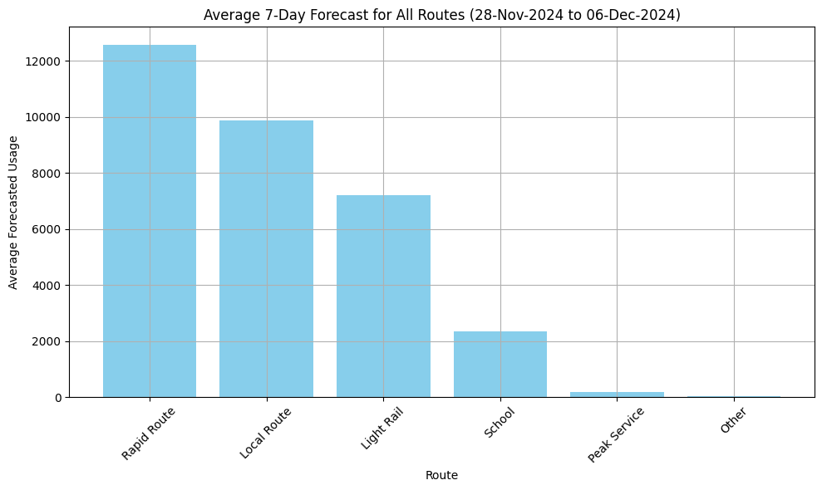

**Final Output: Key Findings**

1. **Rapid Route and Local Route** are the most important routes to the transit system, necessitating sustained investment and operational focus.
2. **Light Rail** exhibits moderate usage, indicating potential for optimization in scheduling or capacity.
3. **Peak Service** and **Other** show limited demand, and their operations might be adjusted to allocate resources more effectively

